Chapter 2 Geological time
Extra worksheet 1: Carbon-14 dating
Science Inquiry Logical/Mathematical, Visual/Spatial
Name: Class: Date:
Carbon-14 dating is also known as radiocarbon dating. Carbon-14 dating is really important for finding the age of organic materials from living things that lived in the last 40 000 to 50 000 years. Organic materials are compounds containing carbon that are produced by living organisms. These compounds include carbohydrates, lipids, proteins and vitamins.

Formation of carbon-14
Carbon-14 is formed high in the atmosphere by cosmic rays (radiation from the Sun) changing nitrogen atoms in to carbon-14 atoms. The carbon-14 atoms combine with oxygen and form radioactive carbon dioxide. The proportion of carbon dioxide molecules which are radioactive is tiny. There is only 1 radioactive carbon atom in 1 000 000 000 000 carbon atoms (1 million million).

Carbon-14 in plants and animals
The radioactive carbon dioxide is absorbed by plants in photosynthesis and made into sugar. Some of the sugar is then converted into many different organic compounds such as proteins, lipids and vitamins in the plant. When the plant is eaten by animals, the radioactive carbon atoms become part of the animal’s body tissues. When organisms die they stop absorbing carbon-14.

Radioactive decay of carbon-14
Carbon-14 atoms decay into nitrogen atoms. In comparison to other types of radioactive decay, the decay of carbon-14 is very fast. The half-life of carbon-14 is 5730 years. Only half of the original radioactive carbon will be left after this time. The decay curve for carbon-14 is shown in Figure 1. The vertical axis shows the percentage of carbon-14 remaining. Carbon-14 decays so fast that radiocarbon dating is not accurate beyond about 50 000 years. Any older than that and carbon-14 dating is not accurate because so little radioactivity is left that is the amount is hard to measure.
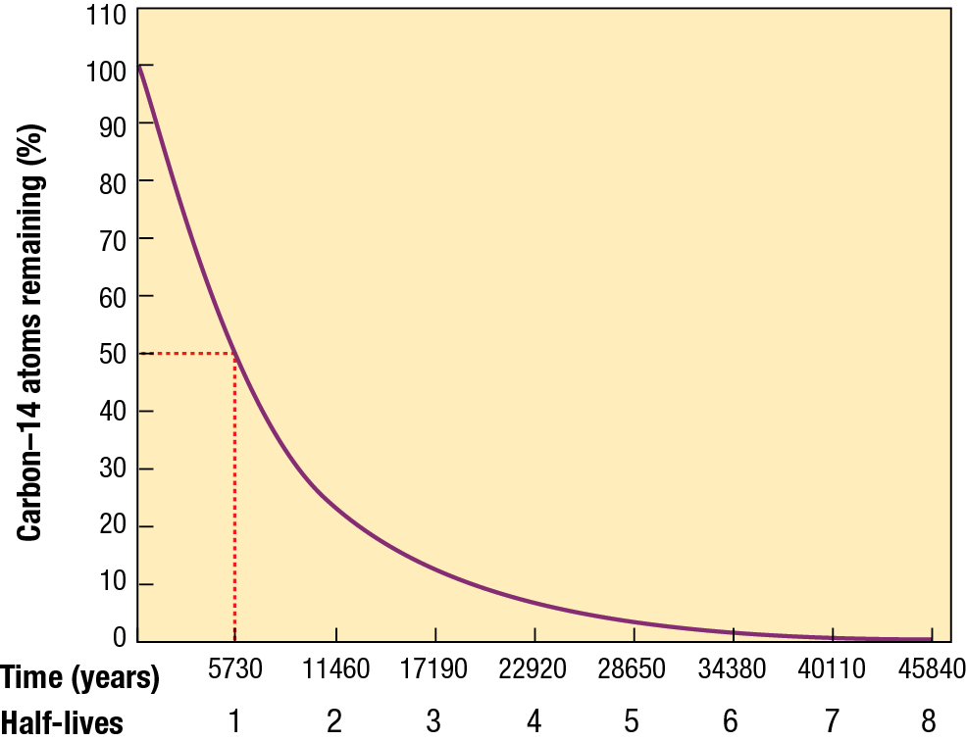
Figure 1
Carbon-14 decay curve.

Questions
1 Define the term organic.

2 Describe the origin of radioactive carbon-14.

3 Explain how radioactive carbon-14 becomes part of compounds in plants.

4 Explain how radioactive carbon-14 becomes part of an animal’s body.

5 Deduce the age of a piece of wood that has half of its carbon-14 remaining.

6 Deduce the age of a piece of bone that has 25% of its carbon-14 remaining.

7 Discuss whether a piece of rock could be dated using the carbon-14 dating method.

8 Explain whether radiocarbon dating could be used on a feather that was thought to be several million years old.

